1. Create a decision table for a Flipkart-style coupon validation system where a coupon is only valid if: (1) the user is logged in, (2) the cart value is above ₹500, and (3) the coupon has not expired. Show all possible combinations and the resulting action (accept/reject).
Ans:
A decision table helps verify all possible combinations of the three coupon conditions.
Conditions
- C1: User is logged in?
- C2: Cart value is above ₹500?
- C3: Coupon has not expired?
The coupon is accepted only when all three conditions are YES.
Conditions / Rules | R1 | R2 | R3 | R4 | R5 | R6 | R7 | R8
C1: Logged in? | Y | Y | Y | Y | N | N | N | N
C2: Cart > ₹500? | Y | Y | N | N | Y | Y | N | N
C3: Coupon not expired? | Y | N | Y | N | Y | N | Y | N
Action | Accept | Reject | Reject | Reject | Reject | Reject | Reject | Reject
Explanation
Rule | Scenario | Result
R1 | Logged in + cart > ₹500 + coupon valid | ✅ Accept coupon
R2 | Logged in + cart > ₹500 + coupon expired | ❌ Reject
R3 | Logged in + cart ≤ ₹500 + coupon valid | ❌ Reject
R4 | Logged in + cart ≤ ₹500 + coupon expired | ❌ Reject
R5 | Not logged in + cart > ₹500 + coupon valid | ❌ Reject
R6 | Not logged in + cart > ₹500 + coupon expired | ❌ Reject
R7 | Not logged in + cart ≤ ₹500 + coupon valid | ❌ Reject
R8 | Not logged in + cart ≤ ₹500 + coupon expired | ❌ Reject
Key point: Since there are 3 binary conditions, there are $2^{3}=8$possible combinations. Only one combination (R1) satisfies all requirements and results in Accept.

2. Draw a state transition diagram for a Paytm login feature that locks the account after 3 failed password attempts and only unlocks after a successful OTP verification.
Ans:
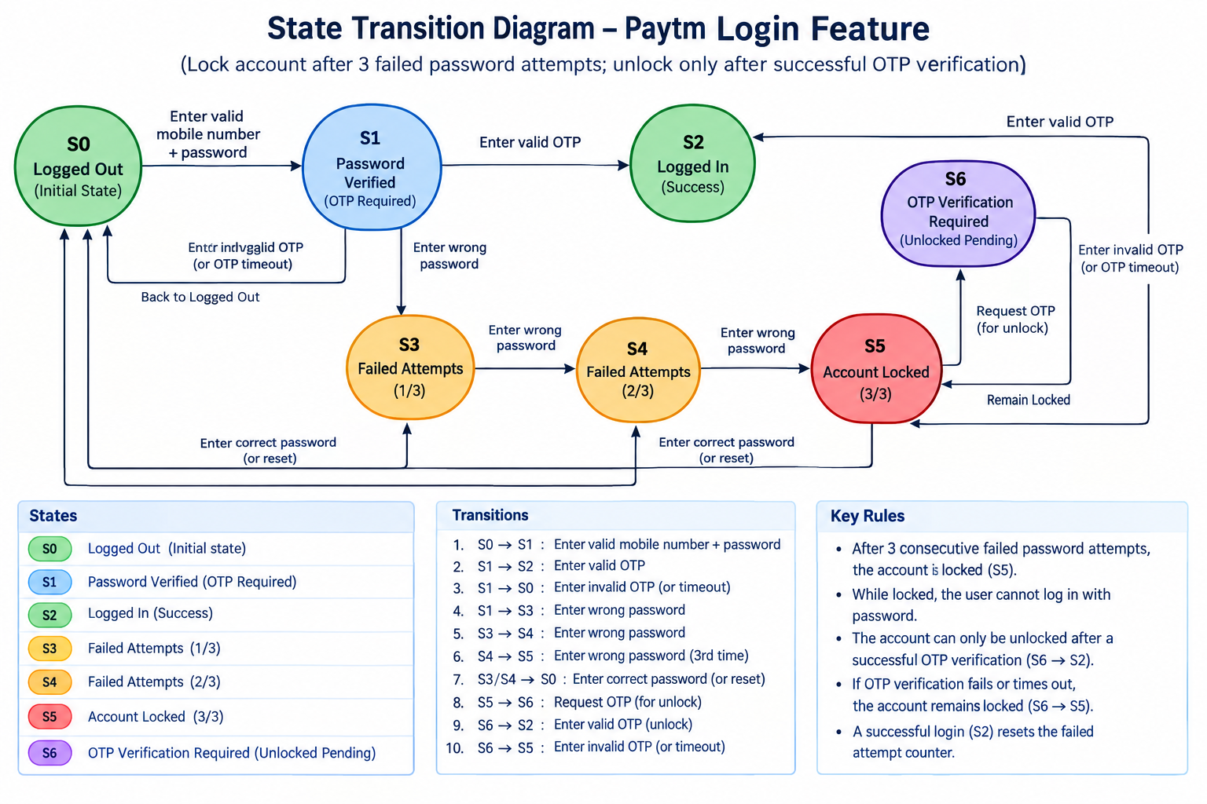

3. Given the following use case: 'A Zomato user can place an order, cancel it before it is prepared, or track the order once prepared,' create a use case diagram and list at least 3 possible test scenarios based on it.
Ans:
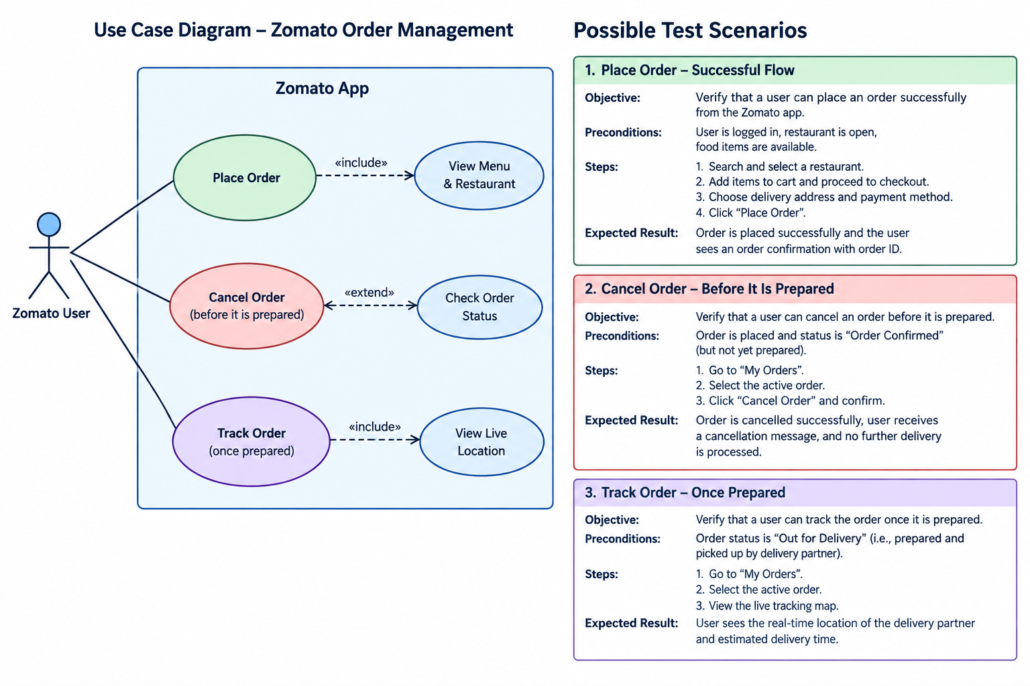
Use Case Diagram – Zomato Order Management
Actor: Zomato User
Main use cases:
- Place Order
- Cancel Order (only before the order is prepared)
- Track Order (once the order is prepared)
┌──────────────────────────────┐
│ Zomato App │
│ │
Zomato User ───────┼──► (Place Order) │
│ │ │
├─────────────┼──► (Cancel Order) │
│ │ [before prepared] │
│ │ │
└─────────────┼──► (Track Order) │
│ [once prepared] │
└──────────────────────────────┘
Test Scenarios
TC | Test Scenario | Steps | Expected Result
TC01 | Place Order Successfully | 1. Log in to Zomato. 2. Select a restaurant. 3. Add food to cart. 4. Enter address and payment details. 5. Place the order. | Order is placed successfully and an order confirmation/order ID is displayed.
TC02 | Cancel Order Before Preparation | 1. Place an order. 2. Open the active order. 3. Ensure the order is not yet prepared. 4. Select Cancel Order and confirm. | Order is cancelled successfully and the user receives a cancellation confirmation/refund information where applicable.
TC03 | Track Order Once Prepared | 1. Place an order. 2. Wait until the order is prepared/dispatched. 3. Open the active order. 4. Select Track Order. | User can view the order status and available delivery-partner/live-location information.
Important negative scenario: If the order is already prepared, the Cancel Order option should be disabled or cancellation should not be permitted according to the system rules.

4. Modify your decision table from Task 1 to include an additional rule: the coupon cannot be used more than twice by the same user. Update the table and explain how this new rule changes the possible outcomes.<br><br><em><strong>Hint:</strong> Add a column for 'Coupon Usage Count' and adjust the actions accordingly.</em>
Ans:
Sure. The key change is that the coupon is now valid only when the user's previous usage count is less than 2. Once the count reaches 2, further use must be rejected.
Updated Decision Table – Coupon Validation
Conditions / Actions | Rule 1 | Rule 2 | Rule 3 | Rule 4 | Rule 5
Coupon is valid? | Y | Y | Y | N | Y
Minimum order value met? | Y | Y | N | Y | Y
Coupon expired? | N | N | N | N | N
Coupon Usage Count < 2? | Y | N | Y | Y | Y
Action: Apply Coupon | ✓ | ✗ | ✗ | ✗ | ✗
Action: Reject – Usage Limit Exceeded | ✗ | ✓ | ✗ | ✗ | ✗
Action: Reject – Minimum Order Not Met | ✗ | ✗ | ✓ | ✗ | ✗
Action: Reject – Invalid/Expired Coupon | ✗ | ✗ | ✗ | ✓ | ✗
Example of the Usage Count Rule
- Usage Count = 0: Coupon can be used.
- Usage Count = 1: Coupon can be used for the second time.
- Usage Count = 2: Coupon cannot be used again.
- Usage Count > 2: Coupon is also rejected.
How the New Rule Changes the Outcomes
Previously, a coupon could potentially be applied whenever the other conditions were satisfied. With the new maximum two uses per user rule, a new rejection outcome is introduced:
If Coupon Usage Count ≥ 2 → Reject Coupon (Usage Limit Exceeded).
This ensures that even if the coupon is valid, the minimum order value is satisfied, and the coupon has not expired, the system will not apply it after the user has already used it twice.

